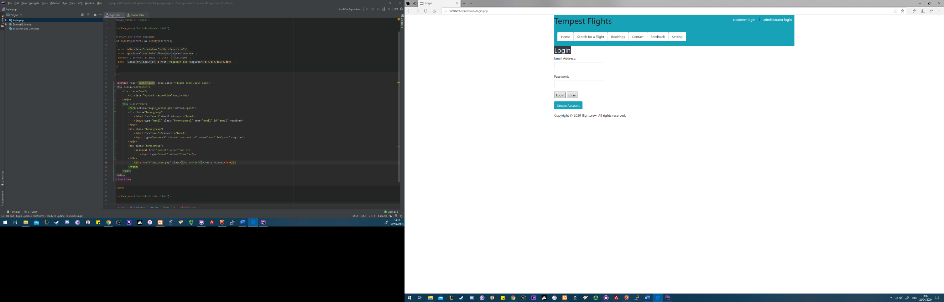Before

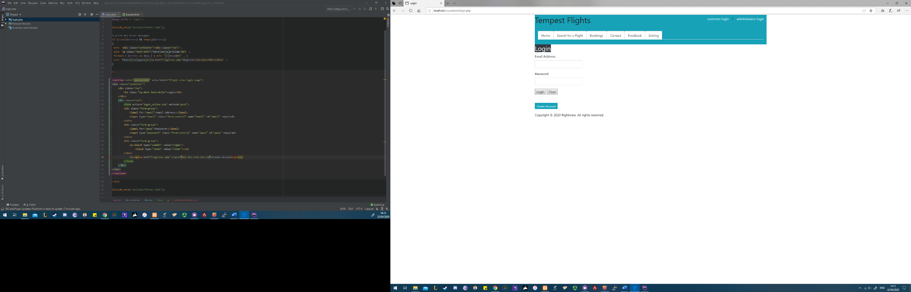After

Before

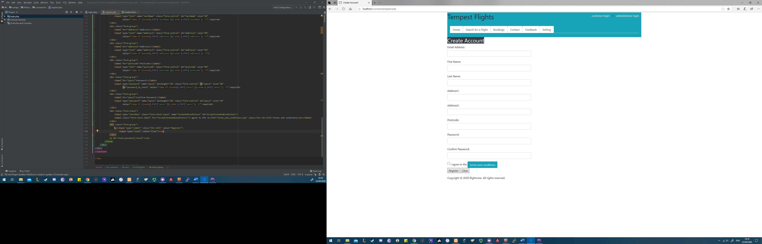

After

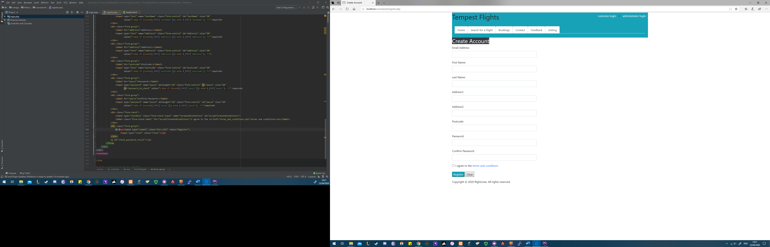

Before

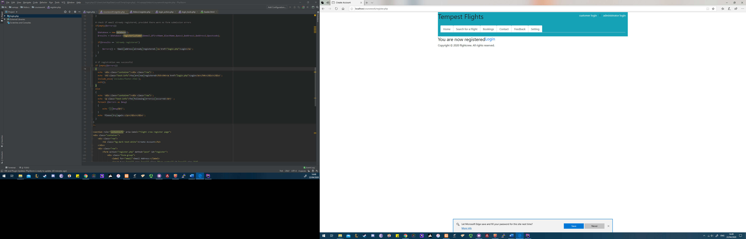

After

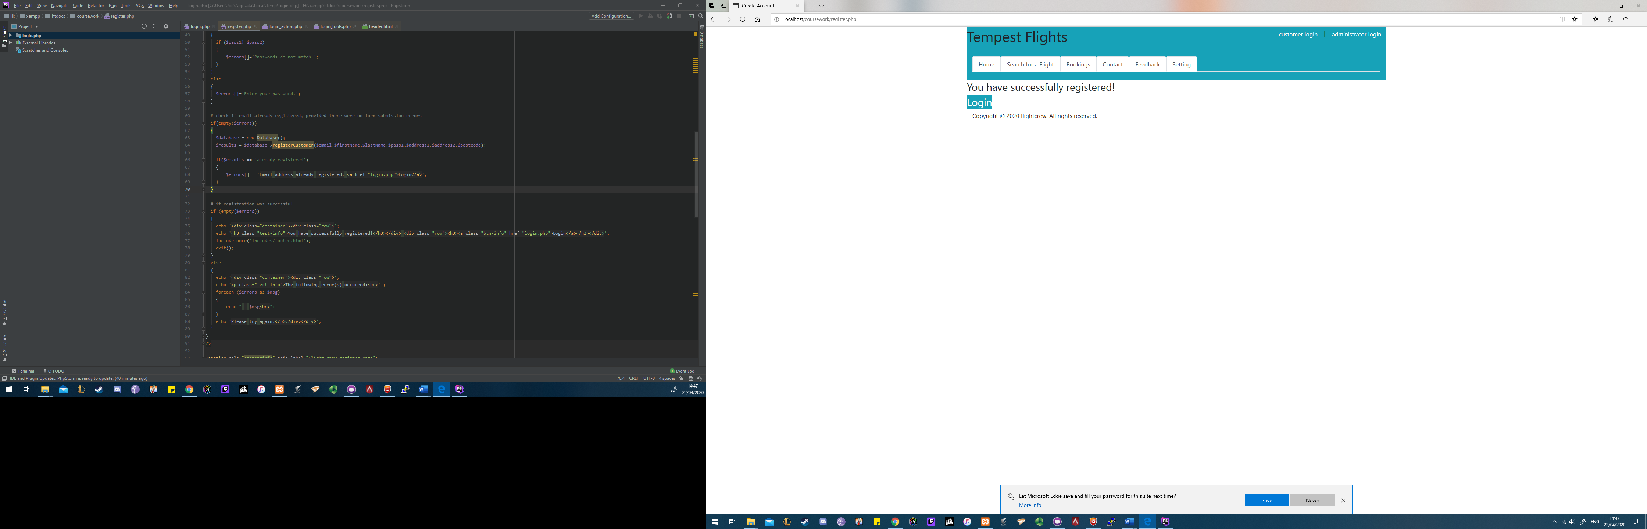

Before

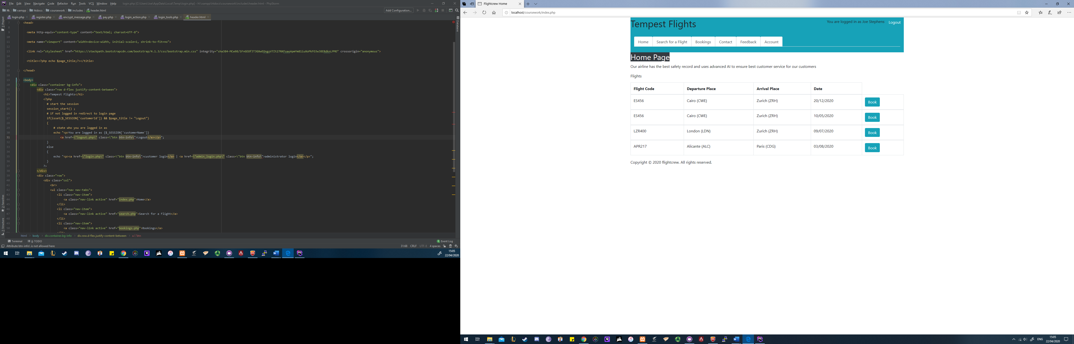

After

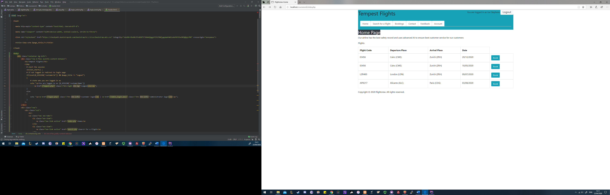

Before



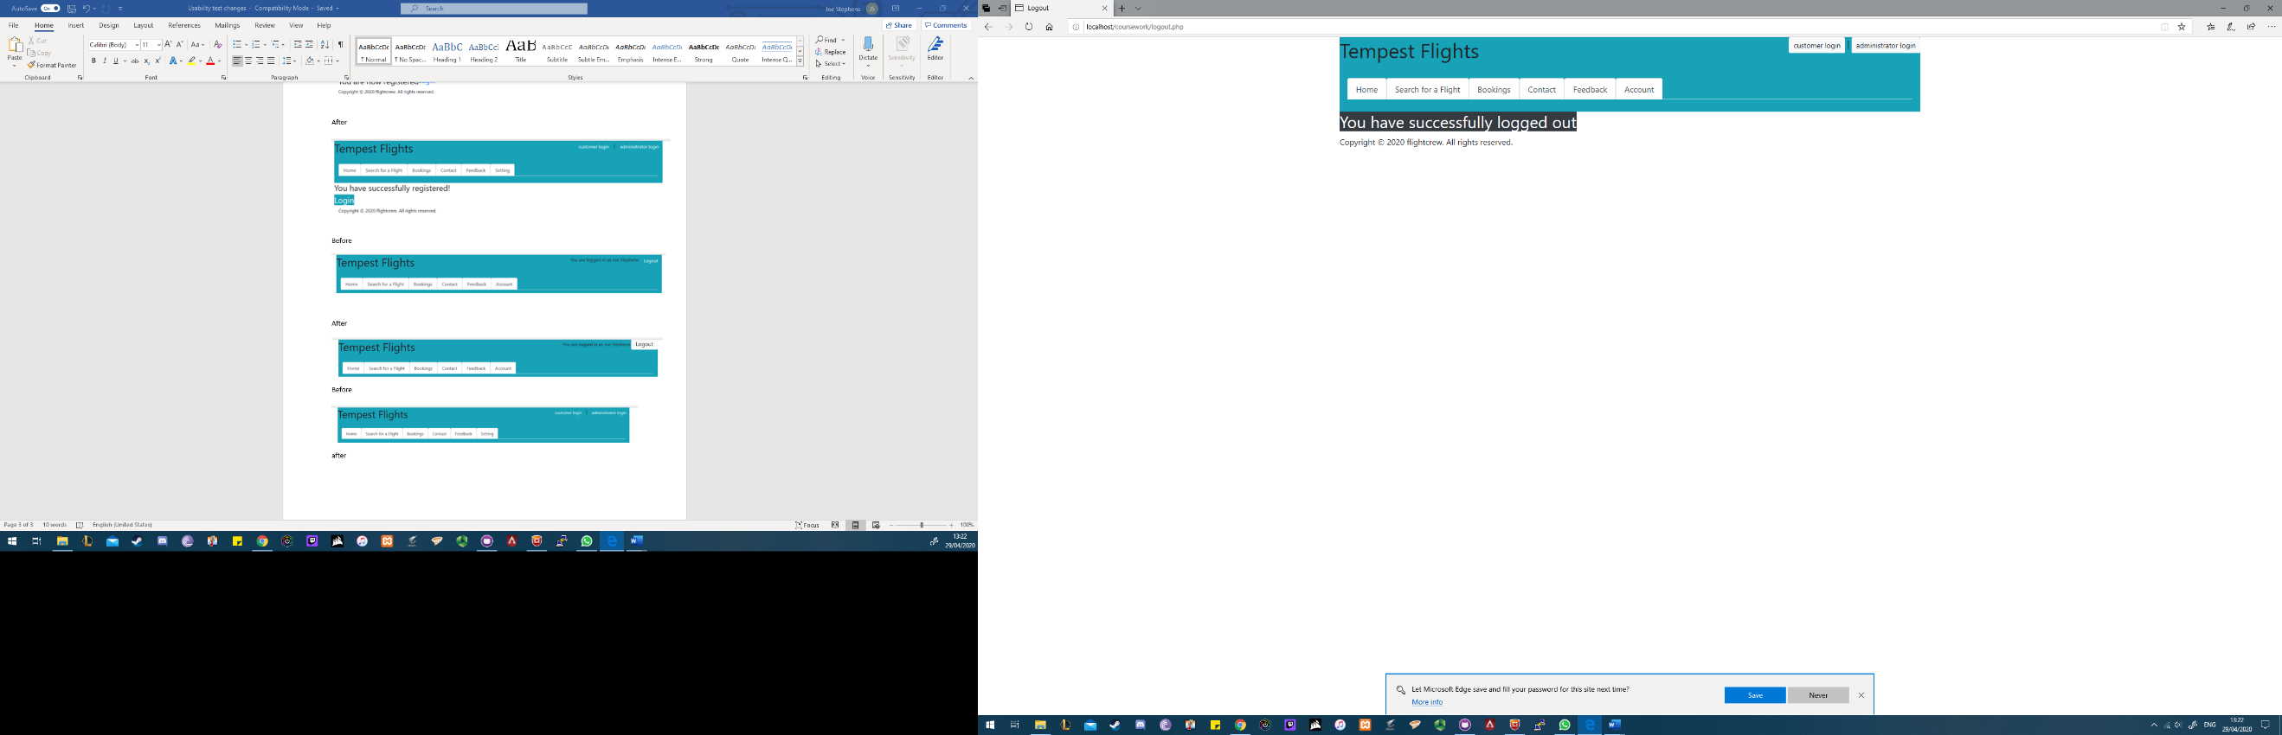after

Before

No logout confirmation check

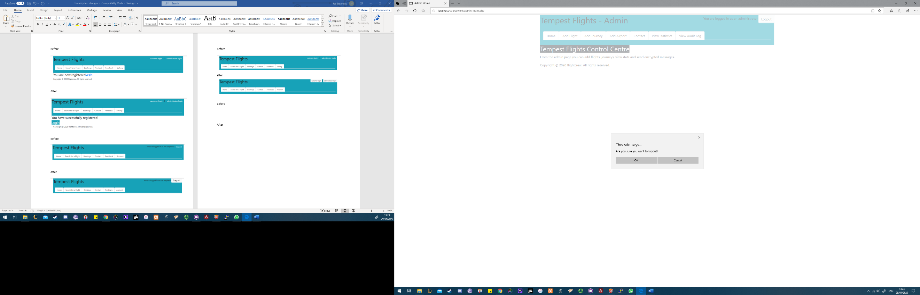After